Latest Round-ups:
Season 2019/20
#5
FA Vase: Gary Higdon of Bradford Town produced the individual performance of the day, bagging a hat-trick in his side’s 7-2 thrashing of Solent University in Southampton. Higdon scored both first half goals to put the visitors two ahead at the break, with a Matty Morris header soon after the interval confirming the Bobcats control of the game. Further goals from Tyson Pollard and Charlie Maddison extended Bradford’s lead, with Higdon then capitalising on a mistake by the home keeper to complete his treble before substitute Lewis Powell added a seventh late on with a fine solo effort. Westbury United were also victorious on their travels, fighting back from an early deficit to beat Andover Town 4-1. Jamie Jordan’s quick-fire double helped turn the game in Westbury’s favour, with Ricky Hulbert and Sam Jordan then firing home either side of the break to book a spot in the next round. Devizes Town will also be involved in the second qualifying round after Liam Mortimer’s 39th minute helped them edge past Stockbridge, while goals from Adam Jones and Kristian Bell helped Cheddar secure a 2-0 win away at Launceston. A hat-trick from Harry Foster helped cap a dramatic 5-3 extra-time win for Wells City over Millbrook. Wells fell behind twice in the first half, but managed to respond each time, when Foster lobbing the keeper for their first before Ross Padfield headed home their second equaliser a minute before the break. There was then an hour of action without the goal being breached before a frantic end to the extra-time period saw four goals scored in the space of eight minutes. Foster handed Wells their first lead of the game in the 112th minute, only for Millbrook to equalise five minutes later as the game headed towards penalties. The hosts had other ideas however, and after Padfield smashes home his second, Foster completed his hat-trick in the final minute to complete the wild ending. Sherborne Town have secured a home tie in the next round after defeating United Services Portsmouth 3-2 at Victory Stadium. Sherborne led at the interval through Ashley Clarke, with Haydn Hodges then helping them retake the lead after the home side had hit back in the early stages of the second half. The Wessex League side responded in kind once again 15 minutes from time, but Sherborne’s third goal proved decisive with Alex Murphy grabbing the late winner. Street enjoyed an easier path through to the next stage of the competition, with two goals from skipper Kameron Andrews and a strike from Ollie Hebbard helping them see off the challenge of Crediton United by three goals to nil. There were eight all-Western League ties which took place on Saturday afternoon, with four home wins, and four away victors. Radstock Town were among the successful away teams, with Morgan Skipp scoring the only goal of the game in their 1-0 victory at Paprika Park against Hengrove Athletic.
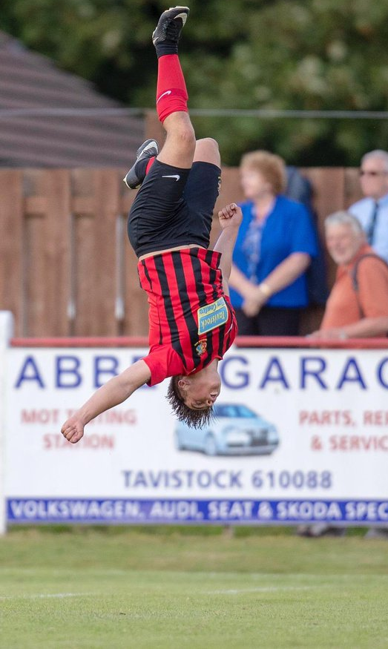
Roman Glass St George put their poor league start behind them with an impressive 2-1 win away at Clevedon Town. Following a goalless first half, Ryan Radford broke the deadlock at the Hand Stadium with a successful spot kick six minutes after the restart. George Box then double Roman Glass’s advantage 20 minutes from time, with Syd Camper claiming a late consolation for the hosts. Cadbury Heath beat First Division outfit Longwell Green Sports by three goals to nil at Springfield, with Matt Huxley scoring in the 15th minute, before Simon McElroy and Eli Nichols added further goals after the break. Shepton Mallet also eased through at the expense of Wellington, with Jack Fillingham maintaining his fine start to the season with a goal in either half. Fillingham scored goals two and three for Mallet, with Joe Morgan having opened the scoring in the sixth minute, before Tyler Davis completed the 4-0 win. Tavistock will be happy with how the month of August played out for them, with a 4-1 victory over Hallen, making it five wins from their opening six fixtures. The visitors actually surged into a third minute lead through Rob Latham, before a brace from Jack Crago, plus goals from Luke Brown and Brannon Roberts completed victory for the Lambs. Almondsbury put up a great fight against Buckland Athletic, taking an early lead before eventually falling to a 4-2 defeat. It took the home side just four minutes to go ahead against their higher-ranked opponents, with Geraint Williams finding the back of the net. Buckland then struck twice in the space of 15 minutes to forge ahead, with Keelan Mastouras levelling the game soon after the interval on his 100th first team appearance for the Almonds. The Premier Division scored twice more after the interval to book their spot in the next round, with Louis Jagger-Kane grabbing a double to add to goals from Lloyd Gardner and Stuart Morgan. Two goals from Jordan Harris proved to be enough for Exmouth Town in their 3-2 win over Brislington, while Jack Sell’s second goal of the game during extra-time led Portishead Town to a 2-1 victory away at Odd Down. It was a tough afternoon for Welton Rovers who conceded twice in either half of their 4-0 defeat against Newton Abbot Spurs, while Keynsham couldn’t overcome an early setback in their 1-0 loss at home to Helston Athletic. Bridport were also knocked out after suffering a 3-0 defeat at Bashley (image above), while Bishops Lydeard and Bristol Telephones were each beaten 3-1 at home by Bodmin Town and Falmouth respectively.
Brannon Roberts celebrates his goal during Tavistock’s FA Vase victory over Hallen. Image courtesy of Dave Crawford.
Stuart Windsor’s 20th minute strike couldn’t stop Calne Town losing 3-1 to Downton, with Bishop Sutton also dumped out following their 4-1 extra time defeat in Devon at the hands of Ivybridge Town. On Sunday, Chipping Sodbury Town suffered extra-time disappointment, falling to a 2-1 defeat away at Wokingham & Emmbrook from Berkshire. Having trailed at the break, the Sods looked for a way back into the game and found it through a now reliable source with Sam Makepeace adding another goal to cap his excellent month in front of goal. That equaliser sent the game to extra-time, but it was the Satsumas who managed to find the decisive goal, capitalising on a red card when substitute Elliott Rushworth fired the winner home from outside the area.
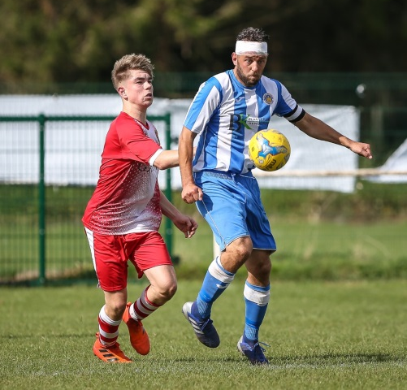
League Action: In the lone Premier Division clash to take place over the weekend, Bridgwater Town handed Plymouth Parkway their first defeat of the season by two goals to nil at Fairfax Park. All of the goalscoring action occurred in the build-up to half-time, with Bridgy striking twice in quick succession to grab all three points. Jack Taylor was the man to open the scoring, completing a one-two with strike partner Steve Murray before rolling the ball into the empty net. Then, in first half stoppage time, the home side were awarded a penalty which the reliable Jake Llewellyn fired home to double their advantage. Meanwhile in the First Division, ten-man Oldland Abbotonians struck late against Corsham Town to secure a 1-0 victory. With the game still goalless midway through the second half, Oldland were handed a major blow in their pursuit of a first home victory this season when Owen McCallum was given his marching orders after picking up his second yellow. The hosts battled on despite the dismissal, and managed to secure all three points in the closing stages when Frank Taylor-Fox guided the ball into the back of the net to score the late match-winner.
Action from Oldland’s 1-0 victory over Corsham via John Cuthbertson.

Be sure to check out the latest podcast, where Ian, Tom & guests recap all the latest news and results from around the Western League. To follow along all season, each broadcast will be available at the following link: http://www.toolstationleague.com/podcasts.php

Latest Results
Saturday 31st August 2019
FA Vase – First Qualifying Round
Almondsbury 2-4 Buckland Athletic 30
Andover Town 1-4 Westbury United
Bashley 3-0 Bridport
Bishops Lydeard 1-3 Bodmin Town
Bristol Telephones 1-3 Falmouth 50
Cadbury Heath 3-0 Longwell Green Sports 102
Calne Town 1-3 Downton 63
Clevedon Town 1-2 Roman Glass St George 70
Devizes Town 1-0 Stockbridge 48
Exmouth Town 3-2 Brislington
Hengrove Athletic 0-1 Radstock Town 44
Ivybridge Town 4-1 AET Bishop Sutton
Keynsham Town 0-1 Helston Athletic 71
Launceston 0-2 Cheddar
Odd Down 1-2 AET Portishead Town 45
Shepton Mallet 4-0 Wellington 92
Solent University 2-7 Bradford Town
Street 3-0 Crediton United 108
Tavistock 4-1 Hallen 111
United Services Portsmouth 0-3 Sherborne Town
Wells City 5-3 AET Millbrook 56
Welton Rovers 0-4 Newton Abbot Spurs

Premier Division
Bridgwater Town 2-0 Plymouth Parkway 232

First Division
Oldland Abbotonians 1-0 Corsham Town

Sunday 1st September 2019
FA Vase – First Qualifying Round
Wokingham & Emmbrook 2-1 AET Chipping Sodbury Town
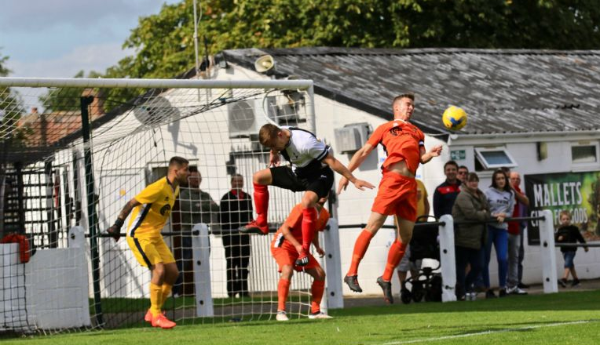

Action from Shepton Mallet’s 4-0 victory over Wellington, courtesy of Haydn Jones.
Upcoming Fixtures
Monday 2nd September 2019
FA Cup Extra Preliminary Round Replay
Melksham Town vs Shepton Mallet 19:30KO
Tuesday 3rd September 2019
FA Cup Extra Preliminary Round Replay
Exmouth Town vs Yate Town 19:30KO
Wednesday 4th September 2019
Premier Division
Bradford Town vs Bridport 19:30KO
Saturday 7th September 2019 (KICK OFF AT 3.00PM UNLESS NOTED)
FA Cup – First Qualifying Round
Bridgwater Town vs Bristol Manor Farm
Plymouth Parkway vs Merthyr Town
Sholing vs Bradford Town
Premier Division
Bitton vs Buckland Athletic
Bridport vs Brislington
Chipping Sodbury Town vs Westbury United
Clevedon Town vs Cribbs
Roman Glass St George vs Tavistock
Shepton Mallet vs Exmouth Town
First Division
Bristol Telephones vs Radstock Town
Calne Town vs Ashton & Backwell United
Cheddar vs Sherborne Town
Corsham Town vs Wincanton Town
Hengrove Athletic vs Devizes Town
Longwell Green Sports vs Lebeq United
Oldland Abbotonians vs Almondsbury
Portishead Town vs Bishop Sutton
Wells City vs Warminster Town
Welton Rovers vs Bishops Lydeard

